|  |  |
| --- | --- |
| cetlogo ***CHEMICAL ENGINEERING TRANSACTIONS***  ***VOL. , 2024*** | A publication of  aidiclogo_grande |
| The Italian Association  of Chemical Engineering  Online at www.cetjournal.it |
| Guest Editors: Marco Bravi, Antonio Marzocchella, Giuseppe Caputo  Copyright © 2024, AIDIC Servizi S.r.l. **ISBN** 979-12-81206-10-6; **ISSN** 2283-9216 | |

Technical feasibility of mead production as a contribution to generate value to beekeepers in Montes de María, Colombia

Jalelys Liceth Leones-Cerpaa, Marco Masonb, Martha María Cuenca Quicazána,\*

aUniversidad de Cartagena, Av. El Consulado Street 30 #48-150, Cartagena de Indias, Bolívar, Colombia (CO).

bUniversidad Nacional Abierta y a Distancia (UNAD) - St. 14 South # 14-23, Bogotá D.C., Colombia (CO)

mcuencaq@unicartagena.edu.co

Montes de María is one of the subregions with the highest honey production rates in Colombia. Despite this, most of it is sold in bulk, without differentiation, which leads to a lower sales price. Beekeepers recognize that the honeys collected come from different geographical and botanical origins and have different characteristics. However, they believe these will not be accepted by consumers, so they sell it at low prices. In Montes de María, there is a beekeepers' cooperative called the Multiactive Cooperative of Organic Beekeepers Montes de María (Cooapomiel). This organization produces, purchases, and sells honey, beekeeping materials, and technical services. In this article, the fermentation process to obtain mead with honey from Montes de María was evaluated. Three different types of honey (from different geographical origins) and two commercial yeasts (*S. cerevisiae*) were used. Brix degrees during the fermentation process were measured. All fermentations started with a must of 24°Bx. After 548 hours at 23°C, all musts reached 8.8 and 10.3 °Bx. One of the yeasts showed slightly faster fermentation, mainly due to its fructophilic capacity. The alcoholic content and volatile acidity were within the range of Colombian regulations for wine-type beverages. All parameters showed variation due to fermentation time. In the future, mead production can be performed by Cooapomiel. Mead quality from this research, investment necessity, and possible commercial partners must be considered.

* 1. Introduction

Beekeeping has experienced significant growth and development in Colombia: substantial increase in honey production and the number of hives established in various regions of the country (Ministry of Agriculture and Rural Development of Colombia (MADR), 2020). There are different beekeepers' associations in Colombia that have extensive experience in bee management. Additionally, in the Colombian Caribbean Region, there are several beekeepers' cooperatives, such as the Multiactive Cooperative of Organic Beekeepers Montes de María (Cooapomiel).

The Caribbean region boasts a wide range of natural resources that significantly contribute to its development potential (Mercado-Gómez et al., 2018). The Montes de María sub-region, strategically located between the Bolivar and Sucre departments, has long faced numerous challenges: low levels of economic development, widespread violence, rampant insecurity, government neglect, and the problem of land concentration (Ortegón et al., 2022). Eeconomy of the Montes de María sub-region is heavily dependent on a variety of activities, including cattle raising, beekeeping, cassava, yams, corn, rice, plantains, tobacco, coffee, avocado, and oil palm cultivation (Colmenares Guerra, 2018).

Beekeeping practice is progressively becoming one of the main economic pillars in the Colombian Caribbean region. Despite the notable expansion of beekeeping activities in the municipalities of Montes de María, its importance as a sustainable productive force has largely been overlooked (Vallone et al., 2023). This growth is closely linked to the diligent efforts of local farmers and the pollination process of flourishing crops, fruit trees, and honey flora (Sperandio et al., 2019). As a result, the region currently boasts one of the highest honey production rates in Colombia. Although official data is lacking, associations report a production of around 900 tons of honey for 2018 in the Montes de María (Ministry of Agriculture and Rural Development of Colombia (MADR), 2020). However, most honey is marketed without any type of distinction. It implies a decrease in the sales price (Ministry of Agriculture and Rural Development of Colombia (MADR), 2020).This is not the right compensation due to arduous efforts undertaken by beekeepers, considering the environmental, geographical circumstances, and behavior of bees, particularly their aggressiveness.

Honey has been significantly utilized as the primary substrate for manufacturing mead through the alcoholic fermentation process using various strains of yeast (Cuenca et al., 2022). Mead, also known as honey wine, is an alcoholic beverage produced through the fermentation of honey diluted in water with other nutrients such as bee pollen, traditionally using the yeast *Saccharomyces cerevisiae* (Starowicz and Granvogl, 2020). Mead is highly sought after in the realm of bee products and has garnered attention in the market due to its remarkable attributes, such as its minimal ecological footprint and positive implications for human welfare, making it an exceptionally advantageous product (Gonzalez-Delgado et al., 2021).

Alcoholic fermentation using honey can be important to improve the overall quality of products. This is achieved by bringing out the inherent properties of honey in such a way that its full potential is utilized (Starowicz and Granvogl, 2020). In this work, local honey was used as an alternative to generate a value-added product, contributing to the economy of the subregion. Consequently, this transformation not only leads to an improvement in the variety of available products but also adds a novel element to the market, thereby attracting a broader consumer base. It allows producers to access previously untapped market segments, expanding their reach and potentially increasing their customer base. Furthermore, this transformation process increases profitability, which can have a significant impact on the livelihoods of beekeepers by providing them with a stable and sustainable source of income.

* 1. Materials and Methods
     1. Materials

In this research, honey from the Montes de María sub-region was used, sourced from the municipalities of El Carmen de Bolívar (Cooapomiel), San Juan Nepomuceno, and San Jacinto, all located in Bolívar, Colombia. Additionally, dehydrated bee pollen from Antioquia, Colombia, was used as a yeast nutrient. Two commercial yeasts were employed: Red Star Premier Classique and Red Star Premier Blanc (Fermentis Lesaffre). Commercial yeasts are widely used in wine production due to their demonstrated adequate fermentative behaviors (Andrade Barreto et al., 2023). A thermostatic bath was utilized to ensure precise temperature control during fermentation (Herrera et al., 2019).

*Alcoholic fermentation tests*

A standardized methodology for mead production was adopted. This approach was chosen to improve process monitoring and estimation of mead quality (Quicazán et al., 2018). Typically, mead is obtained from a must with a 24°Bx (Pereira et al., 2013). Bee pollen was added at a concentration of 4 g/L of must, based on studies indicating improvements in sensory and volatile profiles (Amores-Arrocha et al., 2020).

A simplified process to produce mead is illustrated in Figure 1. Initially, a mass balance was performed to estimate the quantities of honey in the must. Three types of honey were used, differentiated by the location where they were extracted: Carmen de Bolívar, San Juan Nepomuceno, and San Jacinto. Water and pollen were also added. The bee pollen was previously ground to facilitate dissolution in the must. Subsequently, the Brix degrees of the must and honey were measured using a Hanna Instrument digital refractometer. The must was then heated to 60°C for 0.083 hours.

After cooling, when the temperature ranged between 30°C and 37°C, yeast was added. The manufacturer recommended a dose of 30 g/100 L of must for both yeasts. These quantities were weighed into 40 ml amber bottles and mixed with each of the previously prepared musts. After observing carbon dioxide production (bubbling), yeast was added to each must to initiate the alcoholic fermentation process. Alcoholic fermentation was conducted in 250 mL amber glass bottles, with a small bottle left to collect samples. The fermenting musts were stored in a dry place at room temperature (23°C) throughout the fermentation process.

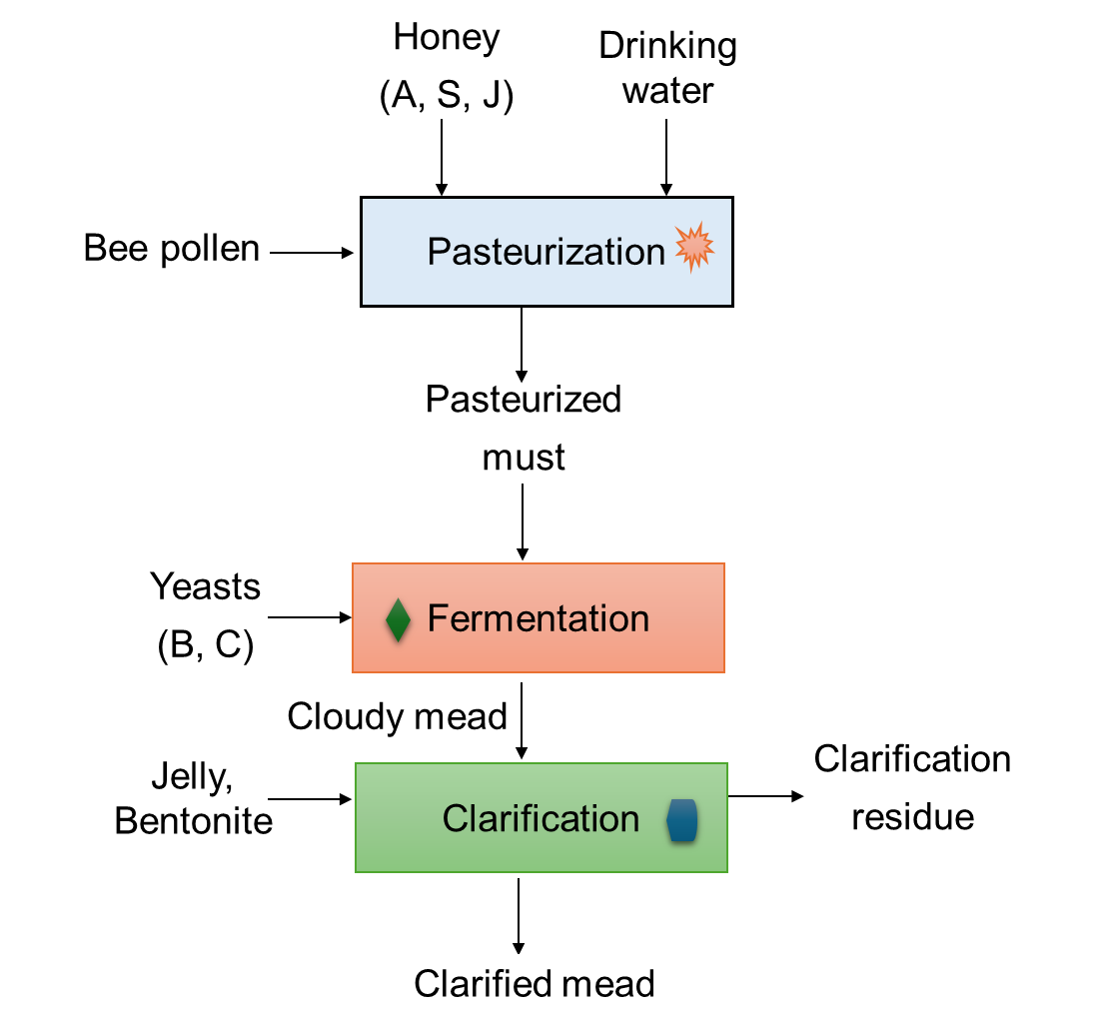

Figure 1: Process flow diagram for mead production (based on Quicazán et al., 2018). Honey extraction sites: San Juan Nepomuceno (S), Carmen de Bolívar (A), and San Jacinto (J), and the yeasts labelled as Red Star Premier Classique (C) and Red Star Premier Blanc (B).

* + 1. Monitoring and characterization of meads

Fermentations were conducted under controlled and constant temperature conditions for 548 hours at 23°C, once stability in Brix degree was achieved, ensuring a stable and optimal environment for biochemical processes. Throughout the fermentation, periodic samples were collected to determine the levels of total soluble solids, which allowed the estimation of the completion of the fermentation process once these values stopped fluctuating over time. Once the fermentation process was completed, the addition of fining agents became essential, incorporating 0.1 g/L of gelatin and 0.3 g/L of bentonite into the system (Quicazán et al., 2018). Finally, the meads underwent a centrifugation process and were packaged in disinfected bottles, thus guaranteeing the integrity and quality of the final product.

The measurement of total soluble solids was conducted using a digital refractometer (0 to 85°Bx), brand SKU: HI 96801, distributed by Hanna Instruments. At the end of the fermentation process, the characterization of the meads involved determining their alcoholic strength and volatile acidity. To determine the alcoholic strength of the meads, measured as Ethanol (% v/v), it was necessary to distill each sample in triplicate. For this test, 50 mL of mead was measured in a 50 mL test tube. Subsequently, a simple distillation setup was employed, involving placing the sample in a round-bottom flask on a thermal blanket, with the addition of boiling beads to facilitate the process. The resulting distillate was collected in the 50 mL tube. After completing the distillation procedure, the sample volume was adjusted with distilled water until reaching the 50 mL mark.

The calculation of alcoholic strength was carried out using a breathalyzer. The determination of volatile acidity, expressed in grams of acetic acid per liter (g acetic acid/L), involved the distillation of 50 mL of each sample. Subsequently, the collected distillate was adjusted to a volume of 50 mL by adding distilled water. To facilitate subsequent evaluation, 3 drops of a 2% ethanolic solution of phenolphthalein were added to the distillate as an indicator. The distillate was then titrated with a 0.1 N NaOH solution.

* + 1. Estimation of materials, equipment, and supplies of the Multiactive Cooperative of Organic Beekeepers Montes de María (Cooapomiel).

In this research, an evaluation of the materials, equipment, and requirements of the cooperative was conducted to analyze the feasibility of starting the production of mead. A series of direct consultations were held with the general manager of Cooapomiel. Among the questions asked were: 'What is the number of members currently belonging to the Cooperative?', 'Could you provide us with information on the production levels of honey and wax during the most recent period (2022 – 2023)?', 'Could you tell us about the different types of products currently offered?', 'What equipment do you have in the plant?', and 'What are the types of products you offer?' The final aim was to determine the feasibility of including mead as one of the value-added products.

The intention behind this effort was to explore the potential benefits and advantages that such an addition could bring to the Cooperative, as well as to evaluate Cooapomiel's current capabilities and resources.

* 1. Results and Discussion

In this study, three different varieties of honey and two different commercial yeasts were used. Consequently, these varieties of honey were designated as follows for the respective locations: San Juan Nepomuceno (S), El Carmen de Bolívar (A), and San Jacinto (J). Simultaneously, the yeasts were labeled as Red Star Premier Classique (C) and Red Star Premier Blanc (B). A total of six (6) different variations of mead were studied.

* + 1. Sugar consumption during fermentation

The results obtained from monitoring the fermentations (triplicate tests) for total soluble solids are shown in Figure 2. Monitoring total soluble solids (°Bx) is commonly used to practically follow the alcoholic fermentation of honey (Blanco et al., 2012). Furthermore, this monitoring technique has recently been used to estimate the relative contributions of two different types of honey (Caicedo et al., 2023). The decrease of Brix degrees occurs mainly as a result of the consumption of sugars (glucose and fructose) present in the must as a contribution from honey during fermentation (Gomes et al., 2013).

Throughout the fermentation process, a decrease °Bx was evident for all meads in this study, as shown in Figure 2. This decrease was found to be faster and more pronounced after 250 hours of fermentation. Subsequently, a perceptible trend was distinguished, with the Brix degrees stabilizing after approximately 300 hours, indicating that the fermentation process had been completed. Although no significant differences were observed between the three different types of honey used in this study, samples containing the yeast strain Red Star Premier Classique (C) showed a more rapid decrease in sugar content. This may be attributed to the inherent fructophilic capacity of this yeast strain (Torres and Torres, 2017).

Figure 2: Monitoring of total soluble solids during alcoholic fermentation.

* + 1. Evaluation of ethanol concentration and volatile acidity

In Colombia, the regulation of alcoholic beverages is governed by Decree 1686 of 2012 and subsequent modifications of the Ministry of Health and Social Protection. According to this decree, wine-type drinks must have an alcohol content greater than 6 alcoholic strengths but no more than 15. The results of this research indicate that the various mead samples are within the limits established for alcoholic strength according to Colombian regulations. According to the results of Table 1, the type of honey had a greater influence on mead production than the yeast strains. Thus, the samples with S honey presented the lowest ethanol content, while there was an increase in ethanol content for J honey, using B yeast. In general, all the samples analyzed presented acceptable alcohol strength considering the regulations and requirements in the fermentation process.

Volatile acidity is considered a sensory defect in mead, attributed to the presence of acetic bacteria that can cause wine sourness (Quicazán et al., 2018). Colombian regulations for table wines (NTC 1244) indicate a maximum value of 1.2 g acetic acid/l for volatile acidity. Therefore, all samples evaluated in Table 1 meet these quality standards, showing lower and very similar values among the different types of mead. High levels of acetic acid are usually related to a higher sugar concentration after alcoholic fermentation is complete. This phenomenon can be attributed to the prolonged fermentation period, which continued for an additional 150 hours after Brix degrees stabilization (Starowicz & Granvogl, 2020).

Table 1: Ethanol concentration and volatile acidity at the end of the fermentation process in honey samples.

|  |  |  |
| --- | --- | --- |
| Mead samples | Ethanol  (% V/V) | Volatile acidity  (g acetic acid/L) |
| BS | 10.5 ± 0.71 | 0.32 ± 0.02 |
| BC | 13.0 ± 1.41 | 0.34 ± 0.03 |
| BJ | 15.0 ± 1.41 | 0.36 ± 0.03 |
| CS | 11.5 ± 0.71 | 0.31 ± 0.03 |
| CC | 13.5 ± 0.72 | 0.34 ± 0.03 |
| CJ | 13.0 ± 1.41 | 0.34 ± 0.02 |

* + 1. General feasibility analysis in Cooapomiel

In response to questions posed to Cooapomiel's general manager, an analysis was carried out, leading to the identification of several key findings. Firstly, it was determined that the Cooperative currently has a total of 34 members. The Cooapomiel warehouse currently houses 3,100 kg of honey and 525 kg of wax for the period between 2022 and 2023. It was verified that Cooapomiel has an estimated production of approximately 15,600 kg per year. Furthermore, it was observed that the equipment at Cooapomiel has remained unused for an extended period of approximately three years. This prolonged downtime can have implications for overall efficiency and effectiveness. The Cooapomiel work area covers two plants: an extractor and a packing house used as a storage warehouse. An inventory revealed a wide range of essential tools and machinery, including a homogenizer, dehumidifier, semi-automatic dosing machine, stainless steel table, 500 L storage tanks, 140 L storage tanks, twelve panel centrifuges, four panel centrifuges, and certifiers. Based on all the aforementioned information, it is possible to affirm that Cooapomiel has the physical resources and essential inputs necessary to carry out mead production. This emerges as a viable alternative to exploit honey that has unfavorable storage conditions, such as a high level of humidity (greater than 20%). Additionally, it is essential to carry out a market study, search for potential business partners, carefully examine the regulations regarding alcoholic beverages in Colombia, and consider associated costs. It is crucial to emphasize that the development of value-added products, such as mead, derived from bee products, has significant implications at the local, regional, and national levels. It contributes to increasing beekeepers' financial profits, motivating them to expand their apiaries and improve overall productivity.

* 1. Conclusions

Beekeeping plays a fundamental role in promoting economic growth in the Colombian Caribbean region. The Montes de María Multiactive Organic Beekeepers Cooperative (Cooapomiel) is a prominent entity that offers a wide range of products. In this study, three varieties of honey from the municipalities of Montes de María were used, namely, San Juan Nepomuceno (S), Carmen de Bolívar (C), and San Jacinto (J), along with two yeast strains: Red Star Premier Classique (C) and Red Star Premier Blanc (C). Analysis of the fermentation process using total soluble solids showed similar trends in all samples, although a slightly faster decrease in Brix degrees was observed in samples containing yeast C. This phenomenon can be attributed to the yeast’s ability to consume sugars faster. The alcoholic strength and volatile acidity levels at the fermentation's end met the standards established in Colombian regulations for wine-type alcoholic beverages. However, it was observed that the honey type exerted a greater influence on these two parameters, with an increase in acetic acid levels due to the continuation of fermentation 150 hours after the Brix degrees had stabilized. It was determined that the necessary equipment is available to facilitate a standardized process to produce mead, after evaluating the resources available in Cooapomiel. However, additional investment and market research are imperative, along with identifying suitable business partners and conducting tax analysis. Consequently, the technical feasibility of mead production in Cooapomiel is supported by the honey quality parameters described in this research, as well as by the recommendations for its implementation in the national beekeeping market.

Acknowledgments

The authors would like to extend their gratitude to the University of Cartagena, the Multiactive Cooperative of Organic Beekeepers Montes de María (Cooapomiel), and the Ministry of Science, Technology, and Innovation of Colombia (MINCIENCIAS) for their invaluable assistance and support in conducting this research.

References

Alzate Mora, D., 2020, Land concentration and Rural, Economic, and Social Development Interest Zones (Zidres) in los Montes de María, María La Baja and Carmen de Bolívar, Prolegómenos, 23(46), 51–70.

Amores-Arrocha, A., Sancho-Galán, P., Jiménez-Cantizano, A., Palacios, V., 2020, Bee pollen role in red winemaking: volatile compounds and sensory characteristics of tintilla de rota warm climate red wines, Foods, 9(8), 1–14.

Andrade Barreto, S. M., Martins da Silva, A. B., Prudêncio Dutra, M. da C., Costa Bastos, D., de Brito Araújo Carvalho, A. J., Cardoso Viana, A., Narain, N., Dos Santos Lima, M., 2023, Effect of commercial yeasts (Saccharomyces cerevisiae) on fermentation metabolites, phenolic compounds, and bioaccessibility of Brazilian fermented oranges, Food Chemistry, 408, 1–9.

Blanco, A., Quicazán, M., Cuenca, M., 2012, Effect of some nitrogen sources in the alcoholic fermentation of honey, Vitae, 19(1), 234–236.

Caicedo, P., Vinueza, C., Cabrera, J., Hidalgo, D., 2023, Preparation of mead from two varieties of honey, Pentaciencias, 5(4), 729–740.

Colmenares Guerra, S., 2018, Credit, coercion and workforce loyalty in a border agricultural exporter: Montes de María (Colombia), 1850-1914, Investigaciones de Historia Económica, 14(3), 174–187.

Cuenca, M., Blanco, A., Quicazán, M., Zuluaga-Domínguez, C., 2022, Optimization and Kinetic Modeling of Honey Fermentation for Laboratory and Pilot-Scale Mead Production, Journal of the American Society of Brewing Chemists, 80(3), 248–257.

Fu, Y., Shi, X., Li, F., Yan, X., Li, B., Luo, Y., Jiang, G., Liu, X., Wang, L., 2023, Fermentation of mead using Saccharomyces cerevisiae and Lactobacillus paracasei: Strain growth, aroma components and antioxidant capacity, Food Bioscience, 52, 102402.

Gomes, T., Barradas, C., Dias, T., Verdial, J., Morais, J. S., Ramalhosa, E., Estevinho, L. M., 2013, Optimization of mead production using Response Surface Methodology, Food and Chemical Toxicology, 59, 680–686.

González-Delgado, A., Cuenca, M., Martínez, E., Rincón, B., 2021, Computer-assisted environmental evaluation of the mead production process on a pilot scale in the Department of Boyacá and Bolívar (Colombia), Ingeniería y Competitividad, 21(1), 10.

Herrera, J., León, L., Torres, Y., Cano, N., Herrera, A., Cuenca, M., 2019, Evaluation and selection of commercial yeast for the alcohol fermentation process of mead, Publicaciones e Investigación, 13(2), 23–30.

Kawa-Rygielska, J., Adamenko, K., Kucharska, A. Z., Szatkowska, K., 2019, Fruit and herbal meads – Chemical composition and antioxidant properties. Food Chemistry, 283, 19–27.

Lin, Y., Zhang, W., Li, C., Sakakibara, K., Tanaka, S., Kong, H., 2014, Factors affecting ethanol fermentation using Saccharomyces cerevisiae BY4742, Biomass and Bioenergy, 47, 395–401.

Mercado-Gómez, Y., Mercado-Gómez, J., & Giraldo-Sánchez, C., 2018, Butterflies in tropical dry forest fragment at Montes of María (Colombia), Ciencia En Desarrollo, 9(2), 35–45.

Ministry of Agriculture and Rural Development of Colombia (MADR), 2020, Bee and Beekeeping Chain. <sioc.minagricultura.gov.co/Apicola/Documentos/2020-09-30 Cifras Sectoriales.pdf> accessed 04.01.2024

Ortegón, T. M., Vinaccia, S., Quiceno, J. M., Capira, A., Cerra, D., Bernal, S., 2022, Social support, resilience, perceived stress, post-traumatic stress, anxiety, depression and health-related quality of life in community leader’s victims of the armed conflict in Montes de Maria, Sucre, Colombia, Revista Eleuthera, 24(1), 158–178.

Pereira, A. P., Mendes-Ferreira, A., Oliveira, J. M., Estevinho, L. M., Mendes-Faia, A., 2013, High-cell-density fermentation of Saccharomyces cerevisiae for the optimisation of mead production, Food Microbiology, 33(1), 114–123.

Quicazán, M., Cuenca, M., & Blanco, A., 2018, Mead production in the context of Colombian beekeeping, Universidad Nacional de Colombia, Bogotá, Colombia.

Sperandio, G., Simonetto, A., Carnesecchi, E., Costa, C., Hatjina, F., Tosi, S., Gilioli, G., 2019, Beekeeping and honey bee colony health: A review and conceptualization of beekeeping management practices implemented in Europe, Science of the Total Environment, 696, 1–12.

Starowicz, M., Granvogl, M., 2020, Trends in food science & technology an overview of mead production and the physicochemical, toxicological, and sensory characteristics of mead with a special emphasis on flavor, Trends in Food Science and Technology, 106, 402–416.

Torres, C. J., Torres, J. C., 2017, Optimization of yeast production with biotechnological interest, Jóvenes En La Ciencia, 3(2), 586–590.

Vallone, M., Orlando, S., Alleri, M., Ferro, M. V., Catania, P., 2023, Honey Production with Remote Smart Monitoring System, Chemical Engineering Transactions, 102, 169–174.